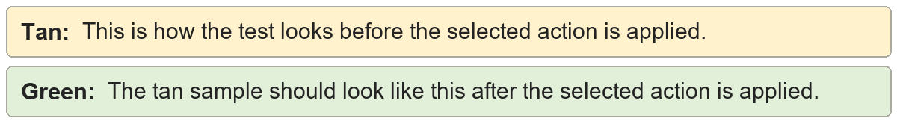
Unused custom styles | Shared style sample.
Unused custom styles | Shared style sample.

Style variant remapping | Shared style sample.
Style variant remapping | Shared style sample.

